GitLab CI/CD with Automated Testing and JAR Packaging

Aim
To implement an automated CI/CD pipeline using Git, GitLab, GitLab CI/CD, Maven, and automated testing, where the application is automatically built, tested, packaged into a JAR file, and stored as a GitLab artifact.

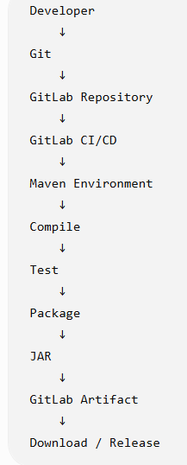
Objective
Students will learn to:
- Create a Java Maven project.
- Create a Git repository.
- Push the project to GitLab.
- Configure GitLab CI/CD.
- Automatically compile the application.
- Automatically execute test cases.
- Stop the pipeline when tests fail.
- Package the application into a JAR file.
- Store the JAR as a GitLab artifact.
Procedure
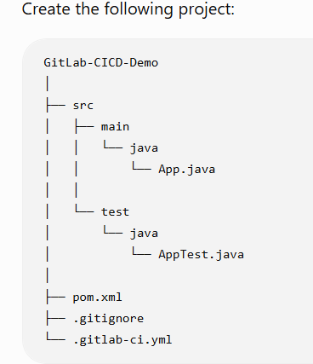

Step 1 — Create App.java
Create:
src/main/java/App.java

public class App {

public static int add(int a, int b) {
return a + b;
}

public static void main(String[] args) {
System.out.println("GitLab CI/CD Application");
}
}

Step 2 — Create AppTest.java
Create:
src/test/java/AppTest.java
Use JUnit:
import org.junit.jupiter.api.Test;

import static org.junit.jupiter.api.Assertions.assertEquals;

public class AppTest {

@Test
public void testAddition() {
assertEquals(5, App.add(2, 3));
}
}

Step 3 — Create pom.xml
<project xmlns="http://maven.apache.org/POM/4.0.0"
xmlns:xsi="http://www.w3.org/2001/XMLSchema-instance"
xsi:schemaLocation="http://maven.apache.org/POM/4.0.0
https://maven.apache.org/xsd/maven-4.0.0.xsd">

<modelVersion>4.0.0</modelVersion>

<groupId>com.example</groupId>
<artifactId>gitlab-cicd-demo</artifactId>
<version>1.0</version>

<properties>
<maven.compiler.source>21</maven.compiler.source>
<maven.compiler.target>21</maven.compiler.target>
<project.build.sourceEncoding>UTF-8</project.build.sourceEncoding>
</properties>

<dependencies>

<dependency>
<groupId>org.junit.jupiter</groupId>
<artifactId>junit-jupiter</artifactId>
<version>5.10.2</version>
<scope>test</scope>
</dependency>

</dependencies>

<build>
<plugins>

<plugin>
<groupId>org.apache.maven.plugins</groupId>
<artifactId>maven-surefire-plugin</artifactId>
<version>3.2.5</version>
</plugin>

</plugins>
</build>

</project>

Step 4 — Create .gitignore
Create:
.gitignore
Put:
target/

Step 5— Initialize Git
Open Git Bash inside the project folder.
cd Desktop/GitLab-CICD-Demo
Initialize Git:
git init
Check:
git status

Add and Commit
git add .
Then:
git commit -m "Create Java application with automated test"

Connect Git to GitLab
Add the GitLab repository:
git remote add origin https://gitlab.com/YOUR_USERNAME/gitlab-cicd-demo.git
Check:
git remote -v
Change the branch to main:
git branch -M main
Push:
git push -u origin main

step 6 — Create GitLab CI/CD Pipeline
Create: .gitlab-ci.yml
image: maven:3.9-eclipse-temurin-21

stages:
- build
- test
- package

build:
stage: build
script:
- mvn compile

test:
stage: test
script:
- mvn test

package:
stage: package
script:
- mvn package
artifacts:
paths:
- target/*.jar
expire_in: 1 week

Step7 — Push the Pipeline
Add the file:
git add .gitlab-ci.yml
Commit:
git commit -m "Add GitLab CI automated testing pipeline"
Push:
git push

Step8 — Observe the Pipeline
Go to your GitLab project.
Select:
Build → Pipelines
You should see:
Pipeline #1

build ✓
test ✓
package ✓

step 9 — Download the JAR
Open the successful package job.
Find:
Job artifacts
Download it.
You will find:
target/
gitlab-cicd-demo-1.0.jar

Result
The GitLab CI/CD pipeline was successfully implemented for the Java Maven application. The source code was pushed to the GitLab repository, and the .gitlab-ci.yml configuration automatically triggered the CI/CD pipeline.

